

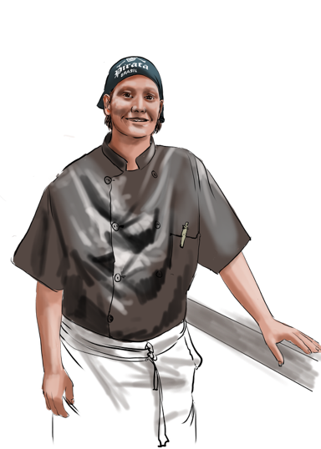
Welcome in Art Restaurant Manezinho.
My name is Raquel Oliveira, and I am chef of Manezinho. On behalf of the staff and the owners, Pieter Adriaans & Cesarina Van Kerchove, we welcome you in our restaurant. We aim to offer you the best of local Azorean cuisine with a bit of an international touch. All our dishes are made from carefully selected and prepared local ingredients.
Please try our meat, our fresh fish, our vegetarian or vegan dishes. Let us surprise you with a suggestion of one of the great wines of Portugal or drink a glass of one of the smaller vineyards of the Azorean Islands.
Enjoy the art of Pieter on display at the walls and (if you are lucky) listen to some live music. Our bar has a wide selection of longdrinks and cocktails.
In summer you can see the sun set from our terrace which has a magnificent view of Pico. Our ambition is to offer you a pleasant stay and make you leave with a smile and a unique memory from our beautiful island of São Jorge.

Raquel Oliveira
